
Focus Brain Therapy
May 14, 2026
Concept/Mockup – Client Feedback

Existing Client website: https://focusbraintherapy.com/
Concept/Mockup: https://focusbrain-kappa.vercel.app/

MENU TABS & VIDEO
- Add Menu Names as shown below.
- Make the video larger but it also needs to look good on the mobile view.
- Add ADA ICON (Plug-in)
Add: Testimonials
Add: Resources
Add: Podcasts
Add Events
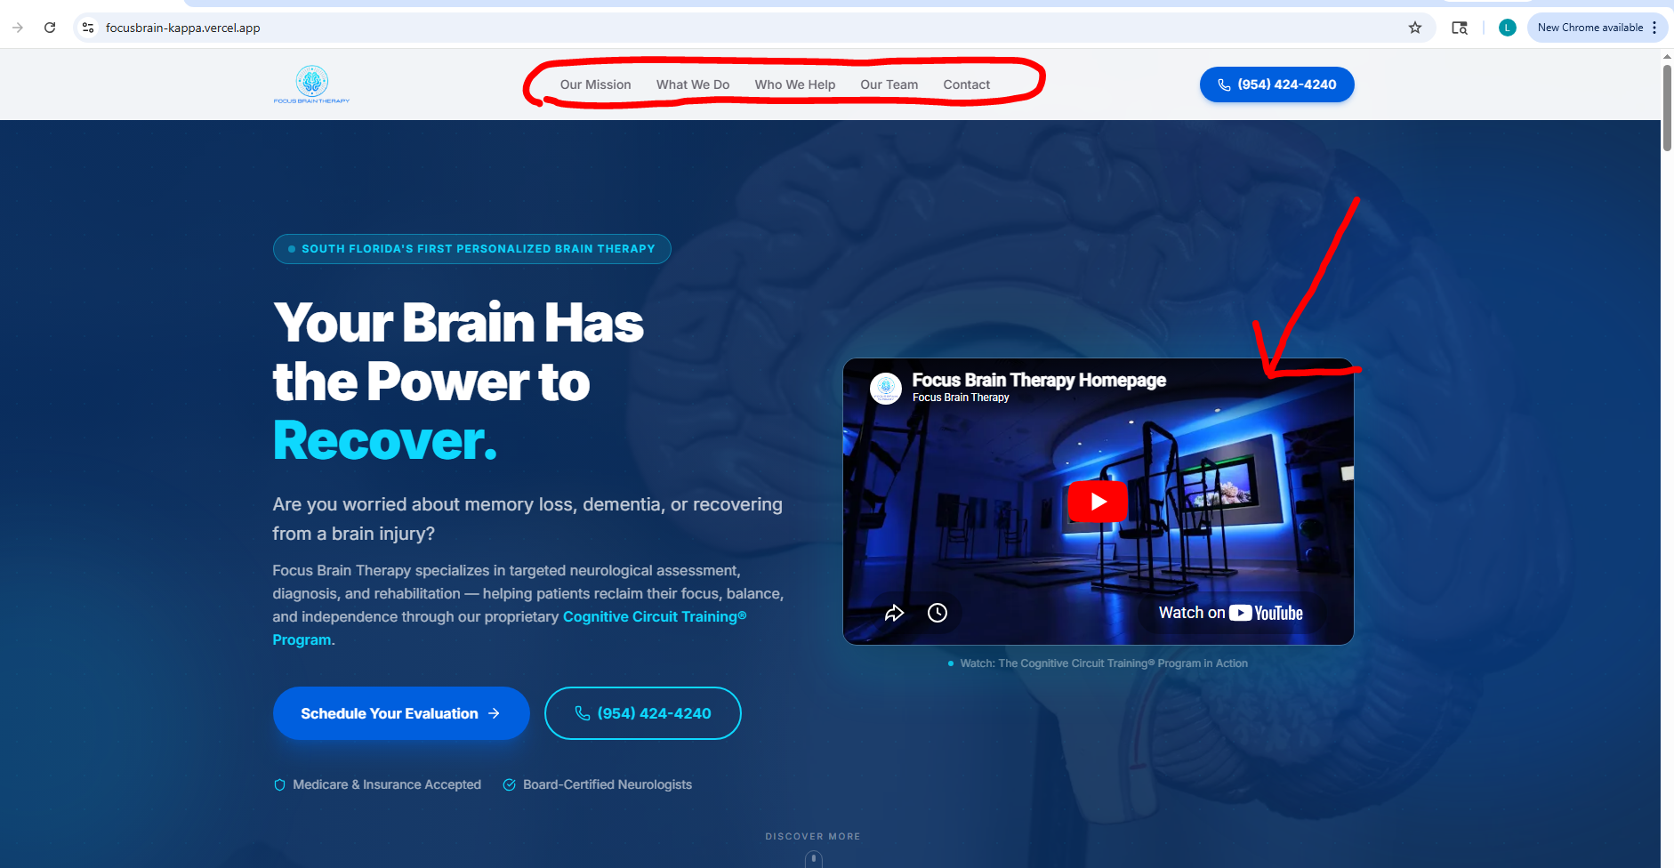

WHO WE HELP SECTION
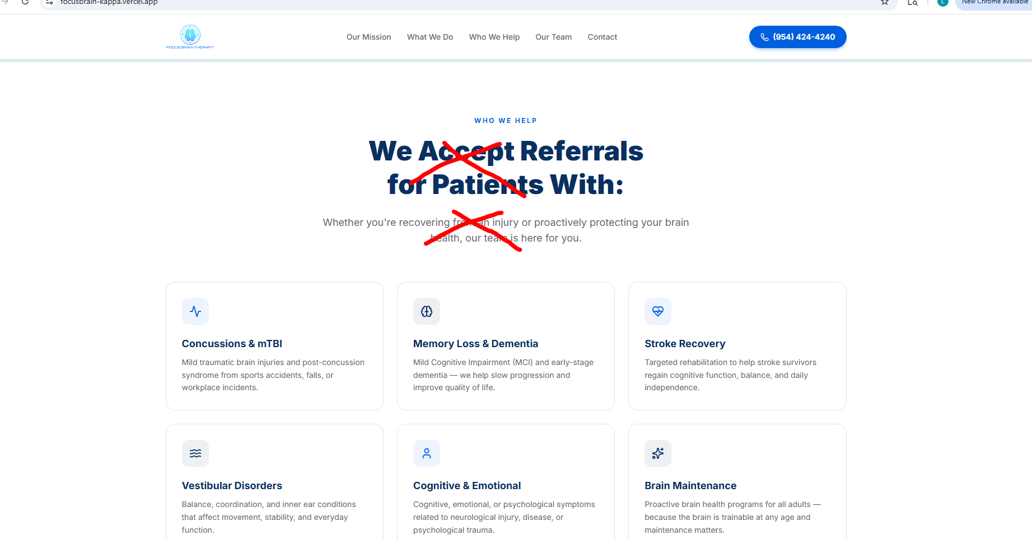
Title:
Our Team Is Here for You
Subtitle:
Whether you’re recovering from an injury or proactively supporting your brain health.
Sub-subtitle:
Flexible Payment Options
Insurance, PPO, Self-Pay, FSA/HSA & Referrals Available

OUR MISSION SECTION
- Swap out this image with one or two from their existing website.
- They don’t have this type of training at this time.
- They will be providing new images/photos later.
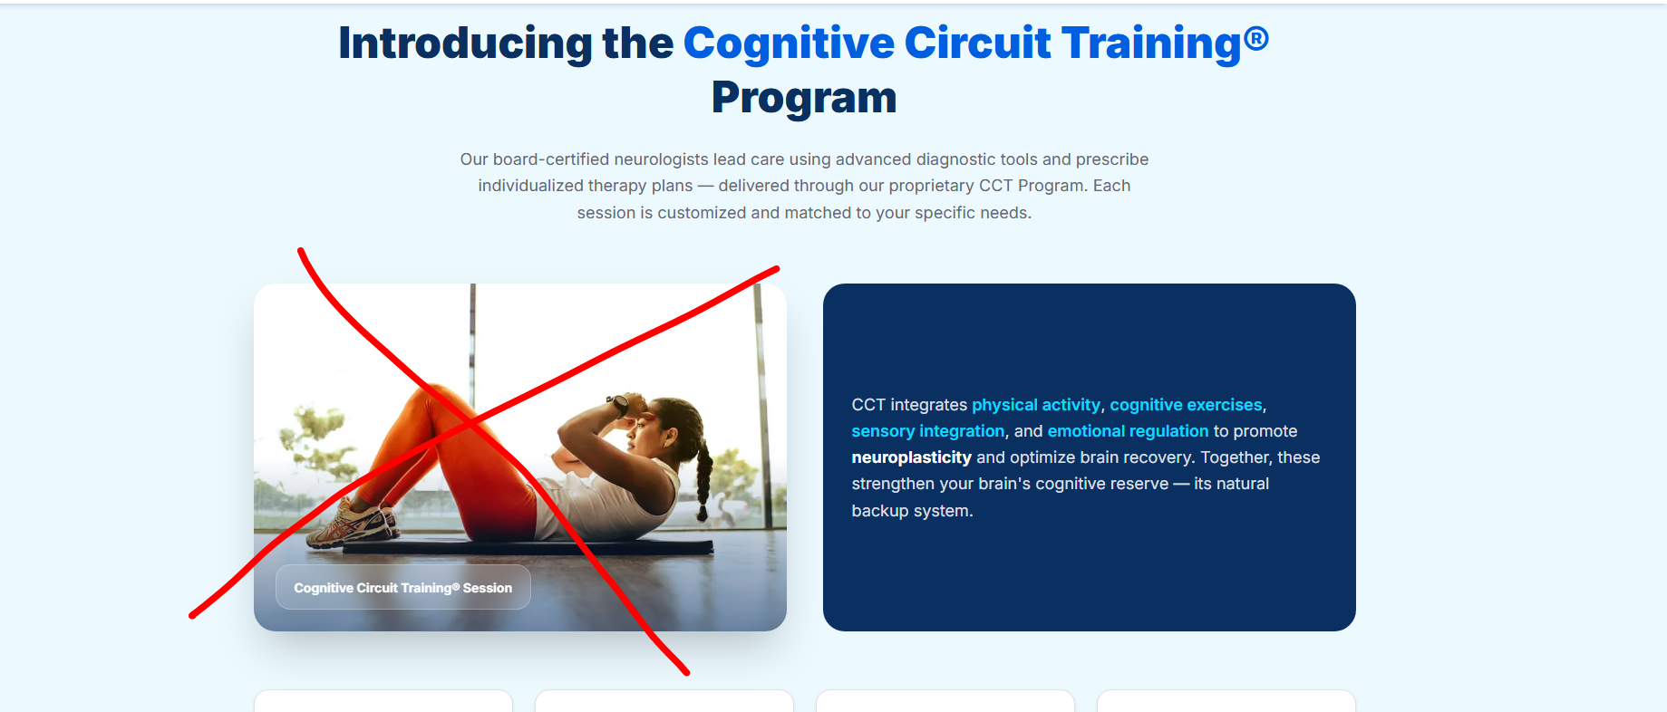
Image examples from existing/current site:
